Enterprise Network Design and Implementation using GNS3

Submitted By
- Name: Basit Imtiaz
- Registration No: NETB01-5697
- Department: BS Telecommunication
- University: Hazara University Mansehra
- Course: Computer Networks
- Instructor: JAWAD
- Submission Date: 18-JULY-2026

Table of Contents
- Introduction
- Objectives
- Software & Tools
- Network Topology
- IP Addressing Scheme
- OSPF Multi-Area Configuration
- RIP Version 2 Configuration
- Route Redistribution
- Static Routing
- Floating Static Routing
- Connectivity Verification
- Testing & Results
- Challenges Faced
- Conclusion

1. Introduction
The objective of this project was to design and implement an enterprise network using Cisco routers in GNS3. Multiple routing protocols including OSPF Multi-Area, RIP Version 2, Static Routing, Route Redistribution, and Floating Static Routing were configured to provide connectivity and redundancy across the network.

2. Objectives
- Design an enterprise network topology.
- Configure IP addressing.
- Configure OSPF Multi-Area Routing.
- Configure RIP Version 2.
- Configure Route Redistribution.
- Configure Static Routing.
- Configure Floating Static Routing.
- Verify end-to-end communication.
- Test network redundancy.

3. Software & Tools
- GNS3
- Cisco IOS 3725 Router
- VPCS
- Windows 10

4. Network Topology
Screenshot 1: Complete GNS3 Topology
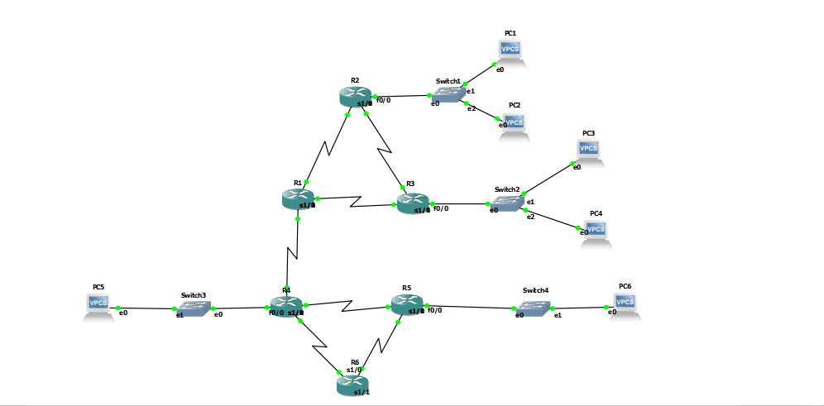
Description:
The network consists of six Cisco 3725 routers (R1–R6) interconnected using serial links. LANs are connected through Ethernet switches with VPCS hosts.

5. IP Addressing Scheme
Device | Interface | IP Address
R1 | S1/0 | 10.0.0.1/30
R1 | S1/1 | 10.0.0.5/30
R1 | S1/2 | 10.0.0.13/30
R2 | Fa0/0 | 192.168.10.1/24
R2 | S1/0 | 10.0.0.2/30
R2 | S1/1 | 10.0.0.9/30
R3 | Fa0/0 | 192.168.20.1/24
R3 | S1/0 | 10.0.0.6/30
R3 | S1/1 | 10.0.0.10/30
R4 | Fa0/0 | 192.168.30.1/24
R4 | S1/0 | 10.0.0.14/30
R4 | S1/1 | 10.0.0.17/30
R4 | S1/2 | 10.0.0.21/30
R5 | Fa0/0 | 192.168.40.1/24
R5 | S1/0 | 10.0.0.18/30
R5 | S1/1 | 10.0.0.26/30
R6 | S1/0 | 10.0.0.22/30
R6 | S1/1 | 10.0.0.25/30

6. OSPF Multi-Area Configuration
The enterprise backbone was configured using OSPF.
- Area 0
  - R1
  - R2
  - R3
- Area 10
  - R4
  - R5
R4 was configured as the Area Border Router (ABR).
Explanation:
OSPF neighbors successfully reached the FULL state, confirming adjacency establishment.

7. RIP Version 2 Configuration
RIP Version 2 was configured between:
- R4
- R5
- R6
Configuration included:
- Version 2
- No Auto Summary
Explanation:
Routers successfully exchanged routing information using RIP Version 2.

8. Route Redistribution
Route redistribution was implemented between OSPF and RIP on R4.
Purpose:
- Exchange OSPF routes into RIP.
- Exchange RIP routes into OSPF.
Result:
All routers learned routes belonging to different routing protocols.

9. Static Routing
Static routes were configured to provide manual routing toward selected remote networks.
Verification:
show ip route static

10. Floating Static Routing
A backup path was created between R5 and R6.
Primary Path:
R6 → R4
Backup Path:
R6 → R5 → R4
Configuration:
Primary Route
ip route 192.168.10.0 255.255.255.0 10.0.0.21
Floating Route
ip route 192.168.10.0 255.255.255.0 10.0.0.26 200
Testing:
After shutting down Serial1/0 on R6, the router automatically switched to the backup path through R5.
Verification:
Before failure
S 192.168.10.0/24 [1/0] via 10.0.0.21
After failure
S 192.168.10.0/24 [200/0] via 10.0.0.26

11. Connectivity Verification
Connectivity was verified using:
ping
and
show ip route
Successful communication was achieved between all LANs.
Examples:
- PC1 → PC2
- PC1 → PC3
- PC1 → PC4
- Router-to-Router Connectivity

12. Testing & Results
The following tests were successfully performed:
Test | Status
OSPF Neighbor Formation | Pass
RIP Neighbor Exchange | Pass
Route Redistribution | Pass
Static Route | Pass
Floating Static Route | Pass
Failover Test | Pass
End-to-End Connectivity | Pass

13. Challenges Faced
During implementation, several issues were encountered:
- Lost router configurations due to improper saving.
- Serial interfaces remained down because of incorrect DCE/DTE settings.
- Incorrect OSPF network statements.
- RIP route advertisement verification.
- Floating static route testing and failover verification.
All issues were resolved through interface verification, routing protocol troubleshooting, and routing table analysis.

14. Conclusion
This project successfully demonstrated the implementation of an enterprise network using Cisco routers in GNS3. OSPF Multi-Area, RIP Version 2, Route Redistribution, Static Routing, and Floating Static Routing were configured and verified. The network provided stable communication, dynamic route exchange, and automatic failover through backup routing, fulfilling the project objectives.

